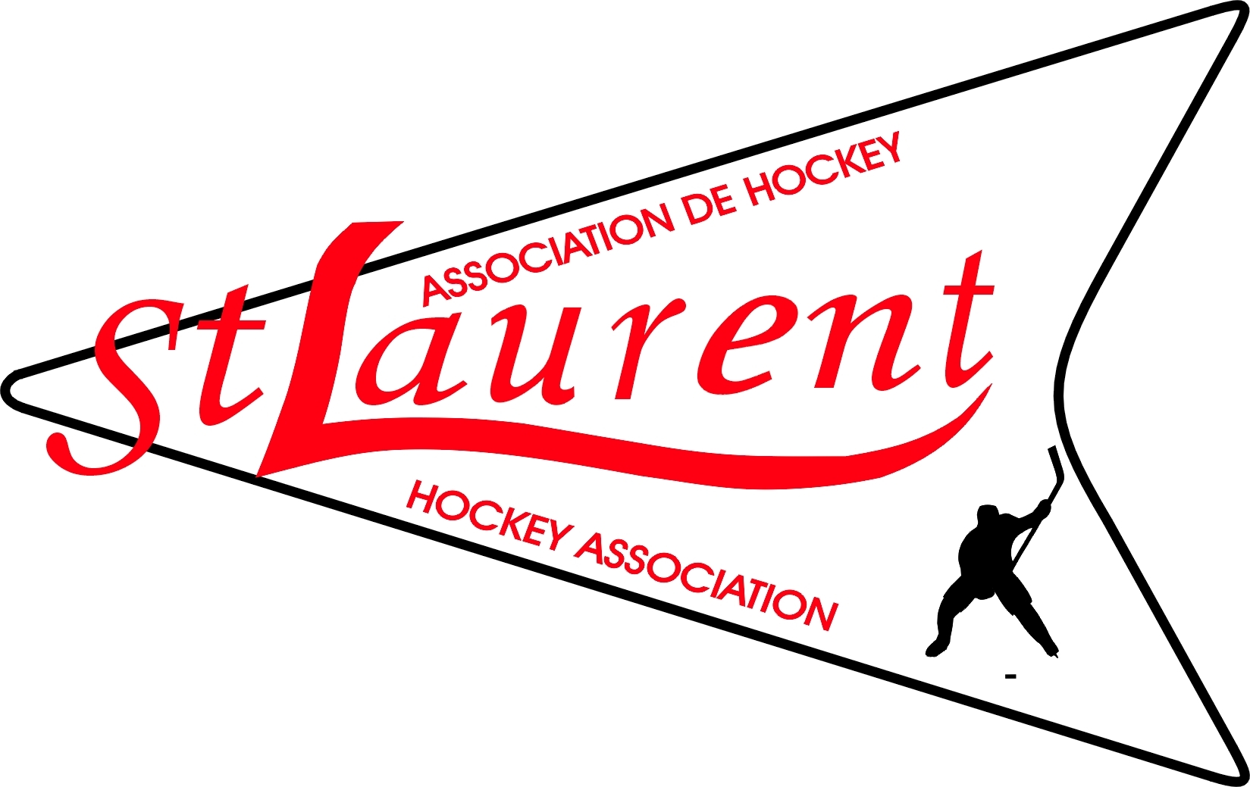
St. Laurent Minor Hockey Association
Registration Form 2008-2009 season

Registration Dates: June 9, June 10, July 28, July 29, 2008. 18:00-21:00 at St. Laurent Complex
Player Number: |  | Player Code:
Player’s Name: |  |  | Division: As per Year of Birth
Mailing Address: |  |  |  | Birth Date:
 |  |  |  | Returning Player: Yes No
Postal Code: | Tel. # (h) |  |  | Level Last Year:

 | Guardian/Father’s Details | Guardian/Mother’s Details
Name:
Address (if different):
City, Postal Code
Home Telephone #:
Work Telephone #:
Cell Phone
E-mail Address:

LEVELS
 | IP Program  5, 6 | Novice  7, 8 | Atom  9, 10 | PeeWee  11, 12 | Bantam  13, 14 | Midget  15, 16, 17
Year of Birth  Age at 31 Dec 2008 | 2003, 2002 | 2001, 2000 | 1999, 1998 | 1997, 1996 | 1995, 1994 | 1993, 1992, 1991
Registration Fee – before July 31  Registration Fee – after July 31 | $350  $375 | $450  $475 | $450  $475 | $460  $485 | $460  $485 | $485  $510

For 2008-09, families with 3 or more players registered with the STLMHA as their ‘home’ association will pay an initial fee of $855 for the first 2 players and receive a discount of $125.00 per child thereafter.
NOTE: To qualify for early registration, fees must be paid in full by 31 July 2008. All NSF cheques shall be repaid in full plus a $25.00 dollar Administration fee. Only Certified cheques, money orders or cash shall be accepted in replacement.

Proof of Age/Residence
Players registering for the first time with the St. Laurent Minor Hockey Association must provide proof of age and residence adddress in order to register with the Association. (Utility bill or a copy of their lease.)

Authorization
I agree to pay the fees as indicated on the Registration Form. I will repay any returned cheque immediately in full as per above note, including the admistration fee of $25 dollars. The player being registered shall abide by the Constitution and Code of Discipline of the St. Laurent Minor Hockey Association, the playing rules and The Code of Discipline of the ODMHA. I also agree that under no circumstances will I hold the above Association or its representatives, or the City of Ottawa or other agents, responsible in case of accident or injury. In case of emergency, if I am not immediately available for consultation, I hereby give permission to the Association’s representative to seek any necessary medical services.

Parent/Guardian Signature: ____________________________________________ Date: _____________________
Print Name Clearly: _________________________________________
Association use only:
Registration form complete: □ Transfer form complete: □
Sign off:
Registrar: _________________________ Date: ___________________

Cheque writer | # of Cheques | Comments
 | 1 2 3

Please make all cheques payable to STLMHA
Mail in Registrations are accepted - Mail To: P.O. Box 44004, Montreal Square, Ottawa, Ontario, K1K 4P8

