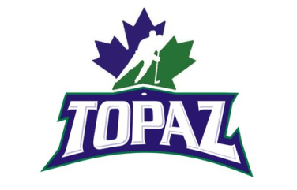
TOPAZ HOCKEY
2013 JERSEY ORDER SHEET

Guarantee, YOU get a Jersey this year!
Fill out the order sheet and have funds available.

- TOPAZ JERSEYS: These Topaz Jerseys are to symbolize Canada with Canucks Colors. As well as representing Topaz Park and Topaz Hockey and of course our passion for the sport.
- CUSTOMIZE: Your name and number. The crest or logo on the front would be the Topaz logo which was designed by Kevin Cave at Fuse Creative. Jerseys provided by Hometown Jerseys and Athletic Knit. The jerseys are similar to roller hockey jerseys made with 100% polyester and have small holes, which means they are lightweight and breathe extremely well.
- COST: Jersey cost is $50.00 each, including shipping, handling and tax. This includes your customized name and number on the back as well as the Topaz logo crest on the front. Get both home and away jerseys at the same time for $95.00.
- PAYMENTS: All Payments must be made before order can be placed, or a $40 Deposit before order is placed.**

CONTACT INFORMATION
FIRST NAME | LAST NAME | PHONE NUMBER | EMAIL ADDRESS

JERSEY INFO
NAME ON BACK OF JERSEY | JERSEY COLOR  (WHITE OR GREEN) | JERSEY NUMBER  (ONLY 2 DIGITS) | SIZE CODE (BELOW)
SIZE CODE: Youth sizes : YSM, YMED and YLRG. Adult sizes : ASM, AMED, ALRG, XLRG and XXLRG
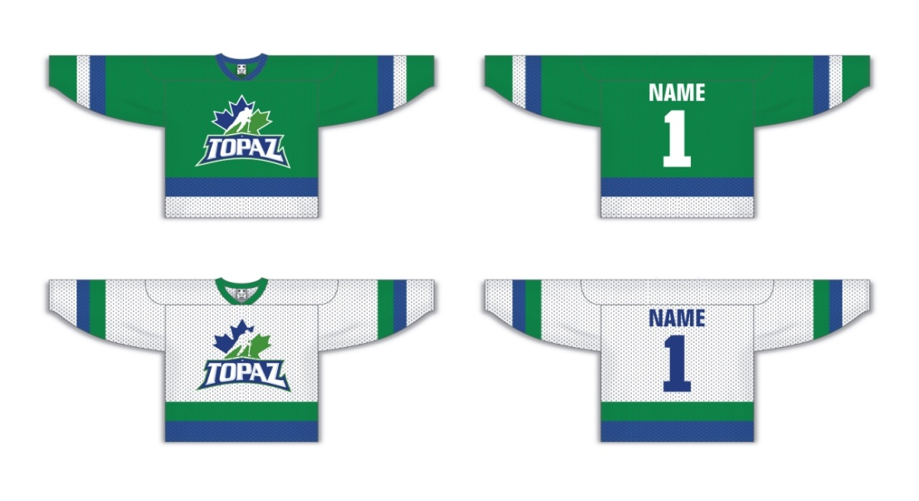
PAYMENT
METHOD OF PAYMENT | AMOUNT PAID | INITIAL BOX FOR PAYMENT
CASH ONLY

RESERVE YOUR JERSEY BY PHONE OR EMAIL:
SHANE NICHOLLS
250-590-7420 / shanejnicholls@hotmail.ca
***We can only place an order with a minimum of 12 jerseys at a time. *All Jersey orders are available in 2-3 weeks, once we have 12 orders .* *But that goes quick when you only need 6 people to place an order*Jersey orders may be ready sooner depending on how busy they get.***

